UTILITY PROGRAMS
A utility program, also called a utility, is a type of system software that performs a specific task, usually related to managing a computer, its devices, or its programs. Most operating systems include several utility programs. You also can buy stand-alone utilities that offer improvements over those included with the operating system.
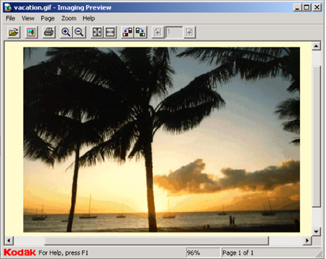
Popular utility programs offer these functions: viewing files, compressing files, diagnosing problems, scanning disks, defragmenting disks, uninstalling software, backing up files and disks, checking for viruses, and displaying screen savers. The following paragraphs briefly discuss each of these utilities.

File Viewer
A file viewer is a utility that allows you to display and copy the contents of a file. An operating system’s file manager often includes a file viewer. For example, Windows Explorer has two viewers: one called Quick View to display the contents of text files and another called Imaging Preview for graphics files (Figure 1). The title bar of the file viewer window displays the name of the file being viewed.
Figure 1: File viewers display the contents of graphic files.

File Compression
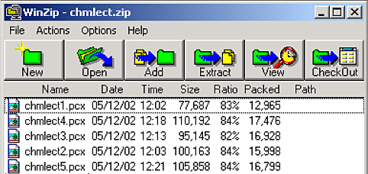
A file compression utility shrinks the size of a file. A compressed file takes up less storage space. Compressing files frees up room on the storage media and improves system performance. Attaching a compressed file to an e-mail message reduces the time needed for file transmission. Uploading and downloading compressed files to and from the Internet reduces the file transmission time.
Compressed files, sometimes called zipped files, usually have a .zip extension. When you receive or download a compressed file, you must uncompress it. To uncompress, or unzip, a file, you restore it to its original form. Two popular stand-alone file compression utilities are PKZIP™ and WinZip® (Figure 2).
Figure 2: Zipped files consume less storage space.

Diagnostic Utility
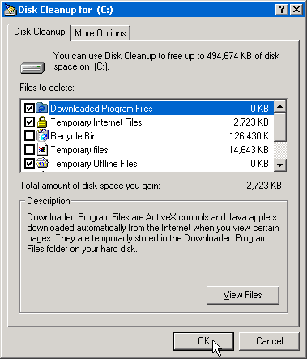
A diagnostic utility compiles technical information about your computer’s hardware and certain system software programs and then prepares a report outlining any identified problems. For example, Windows includes the diagnostic utility, Dr. Watson, which diagnoses problems as well as suggests courses of action.

Disk Scanner
A disk scanner is a utility that (1) detects and corrects both physical and logical problems on a hard disk or floppy disk and (2) searches for and removes unwanted files. A physical problem is one with the media such as a scratch on the surface of the disk. A logical problem is one with the data, such as a corrupted file allocation table (FAT). Windows includes two disk scanner utilities: ScanDisk and Disk Cleanup. ScanDisk detects and corrects problems. Disk Cleanup searches for and removes unnecessary files such as temporary files (Figure 3).

Disk Defragment Utility
A disk defragment utility reorganizes the files and unused space on a computer’s hard disk so the operating system can access data more quickly and programs can run faster. When an operating system stores data on a disk, it places the data in the first available sector on the disk. Although it attempts to place data in sectors that are contiguous (next to each other), this is not always possible. When the contents of a file are scattered across two or more noncontiguous sectors, the file is fragmented. Fragmentation slows down disk access and thus the performance of the entire computer. Defragmenting the disk, or reorganizing it so the files are stored in contiguous sectors, solves this problem. Windows includes a disk defragmenter, called Disk Defragmenter.
Figure 3: Disk Cleanup will remove unnecessary files.

Uninstall Utility
An uninstall utility removes an application, as well as any associated entries in the system files. When you install an application, the operating system records the information it uses to run the software in the system files. The system file entries will remain if you attempt to remove the application from your computer by deleting the files and folders associated with the program without running the uninstaller. Most operating systems include an uninstaller. You also can purchase a stand-alone program, such as McAfee’s UnInstaller.

Backup Utility
A backup utility allows you to copy, or backup, selected files or your entire hard disk onto another disk or tape. During the backup process, the backup utility monitors progress and alerts you if it needs additional disks or tapes. Many backup programs will compress files during this process, so the backup files require less storage space than the original files.
For this reason, you usually cannot use backup files in their backed up form. In the event you need to use one of these files, a restore program reverses the process and returns backed up files to their original form. Backup utilities include restore programs.
You should back up files and disks regularly in the event your originals are lost, damaged, or destroyed. Windows includes a backup utility. Some users opt to back up their files to an Internet hard drive. An Internet hard drive, sometimes called online storage, is a service on the Web that provides storage to computer users. A separate paper discusses backup strategies in more depth.

Antivirus Program
An antivirus program is a utility that prevents, detects, and removes viruses from a computer’s memory or storage devices. A virus is a program that copies itself into other programs and spreads through multiple computers. Some malicious programmers intentionally write virus programs that destroy or corrupt data on a computer. A separate paper discusses antivirus programs and viruses in more depth.


Screen Saver
A screen saver is a utility that causes a monitor’s screen to display a moving image or blank screen if no keyboard or mouse activity occurs for a specified time period (Error: Reference source not found). When you press a key on the keyboard or move the mouse, the screen returns to the previously displayed image.
Screen savers originally were developed to prevent a problem called ghosting, in which images could be permanently etched on a monitor’s screen. Ghosting is not a problem with today’s monitors. Still, screen savers are popular for security, business, or entertainment purposes. To secure a computer, you can configure your screen saver so a user must enter a password to stop the screen saver and redisplay the previous image. Some screen savers use push technology, which enables you to receive updated and new information each time the screen saver displays. Push technology occurs when Web-based content downloads automatically to your computer at a regular interval or whenever the Web site updates.
Figure 4: A sample screen saver.
An operating system often includes several screen savers. You also can purchase screen savers or download them from the Web.

